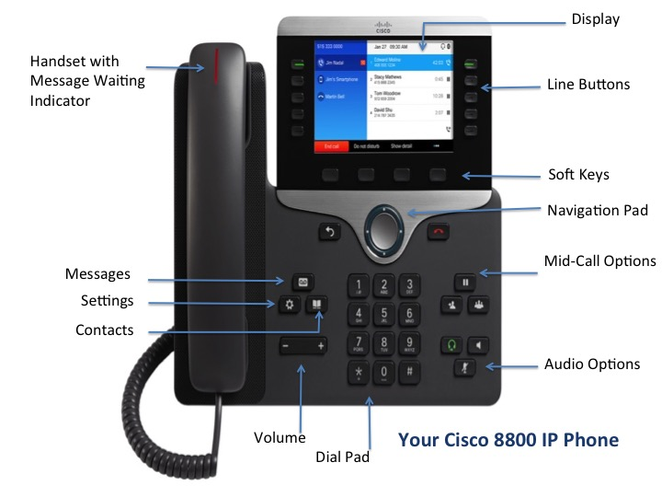

# Cisco 8800 IP Phone

# Navigating

## Line Buttons

Line buttons are located on the left side of the display. These are used to select the line you want to use.

## Session Buttons

Session buttons are located on the right side of the display. The available options for these buttons will change depending upon what function you are using at the time.

* Press the button next to the phone icon to place the first call on hold and dial another number. This allows you to make a quick call without ending the first call.
* Press the clock icon to view recent calls.
* When you have a voicemail you will see a voicemail waiting icon.

## Softkeys

Softkeys dynamically change to reflect current options. Four softkey buttons are located below the phone screen. You can press the More (•••) softkey when available to reveal additional options.

## Scrolling

To scroll though a menu or list, press up, down, left or right on the four-way Navigation cluster.



A scroll bar on the screen indicates your relative position within a list.

# Dialing

To place a call, pick up the handset and enter a number, or try one of these alternatives.

## Redial Last Number

Press Redial to redial your primary line. To redial on another line, press the desired line button first.

## Dial On-Hook

1. Enter a number when the phone is idle.
2. Lift the handset or press Call, Headset **, Speakerphone **, or Select.

## Speed Dial

To set up speed dial numbers, please send an email to [telecom@brown.edu](mailto:telecom@brown.edu) or call 32007.

# Answering

New calls display in these ways:

* A flashing amber line button
* An animated icon  and caller ID
* A flashing red light on your handset

To answer the call, lift the handset. Or, press the flashing amber session button, Answer, the unlit Headset button, or the Speakerphone button.

# Transfer

1. From an active call, press Transfer .
2. Enter the transfer recipient’s extension or telephone number.
3. Press Transfer again either before or after the party answers to complete the transfer.

# Conference

1. From an active call, press Conference 
2. Make a new call.
3. Press Conference again either before or after the party answers. The conference begins.
4. Repeat these steps to add additional participants. The conference call ends when all participants hang up.

## Join Calls

You can also join an active call with a held call either on the same line or across lines.

1. From an active call, press Conference.
2. Press Active calls to select the held call.
3. Press Conference again to join the calls.

## View and Remove Participants

During a conference call, press Show details. To remove a participant from the conference, scroll to the participant and press Remove.

# Cisco 8800 IP Phone

# Hold

1. Press Hold **. The hold icon appears and the line button flashes green.
2. To resume a call from hold, press the flashing green Line button, Resume, or Hold.

# Mute

1. While on a call, press Mute **. The button glows to indicate that mute is on.
2. Press Mute again to turn mute off.

# Call History

To view your missed, placed and received calls, do the following:

1. Press the clock icon session button on the right side of the display.
2. Select a line to view. Your phone displays the last 150 missed, placed and received calls.
3. To view details for a call, scroll to the call, press More (•••), and then press Details.

## View Missed Calls Only

1. Open your call history.
2. Press Missed calls.

## Dial from Call History

1. View your call history, or navigate to your missed or placed calls.
2. Scroll to a listing and lift the handset, or press Select.

# Directories

1. Press the Contacts icon button ** on the dial pad.
2. Scroll and select a directory.
3. Use your keypad to input search criteria.
4. Press Search.
5. To dial, scroll to a listing and press the Dial button.

# Voicemail

When you receive a new voicemail message, you will notice these three message indicators:

* A solid red light on your handset
* A voicemail icon on the right side of the display.
* You will also receive an email with a .wav file attachment containing your message.

If you forget your voicemail PIN, send an email to [voicemail@brown.edu](mailto:voicemail@brown.edu) or call 32007.

## Listen to Messages

Press the Messages icon button  and follow the voice prompts. To check messages for a specific line, press the line button first.

## Divert to Voicemail

Press the Declinesoftkey when the call is ringing, active, or on hold. Decline sends a call directly to your voicemail.

# Forward Calls

1. To forward calls on your primary line to another internal 5-digit number, press the Fwd All softkey and enter the number.
2. To forward to voicemail, press the Messages icon button.
3. Look for confirmation of the forward on your phone display.
4. To cancel call forwarding, press Fwd Off.

**Quick Reference Guide**

**Quick Reference Guide**

**Quick Reference Guide**