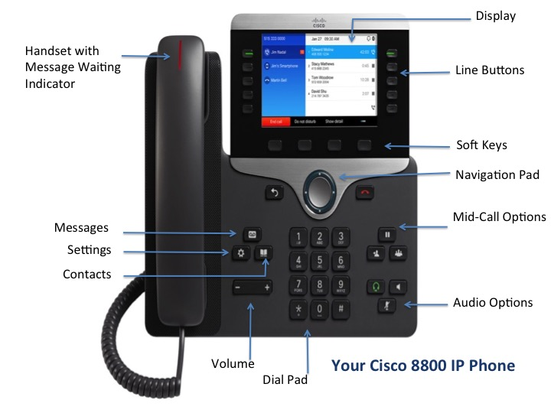

# Cisco 8800 IP Phone

# Navigating Your Phone

## Line Buttons

Line buttons are located on the left side of the phone screen. Buttons that are not assigned to phone lines can be used for speed-dials and other features.

## Session Buttons

Session buttons are used to perform tasks such as answering a call, resuming a held call, or initiating phone functions, such as displaying missed calls. Each call on your phone is associated to a session button. Session buttons are located on the right side of the phone screen.

## Softkeys

Softkeys are feature buttons that dynamically change to reflect your current options. Four softkey buttons are located below the phone screen. You can press the More softkey when available to reveal additional softkeys. 

## Scrolling

To scroll though a menu or list, press up, down, left or right on the four-way Navigation cluster.



A scroll bar on the screen indicates your relative position within a list.

# Dialing

To place a call, pick up the handset and enter a number, or try one of these alternatives.

## Redial Last Number

Press Redial to redial your primary line. To redial on another line, press the desired line button first.

## Dial On-Hook

1. Enter a number when the phone is idle.
2. Lift the handset or press Call, Headset **, Speakerphone **, or Select.

## Speed Dial

Enter a speed-dial item number and press SpeedDial. You may also have speed dials assigned to some buttons along the left side of your phone.

# Answering

New calls display in these ways:

* A flashing amber line button
* An animated icon  and caller ID
* A flashing red light on your handset

To answer the call, lift the handset. Or, press the flashing amber session button, Answer, the unlit Headset button, or the Speakerphone button.

# Transfer

1. From an active call, press Transfer .
2. Enter the transfer recipients extension or telephone number.
3. Press Transfer again either before or after the party answers to complete the transfer.

# Conference

1. From an active call, press Conference 
2. Make a new call.
3. Press Conference again either before or after the party answers. The conference begins and the phone displays “Conference.”
4. Repeat these steps to add additional participants.

The conference call ends when all participants hang up.

## Join Calls

You can conference the active call with the held calls either on the same line or across lines.

* From an active call, press Conference.
* Press Active calls to select the held call, and press Conference again to create the conference.

## View and Remove Participants

During a conference call, press Show Details. To remove a participant from the conference, scroll to the participant and press Remove.

# Cisco 8800 IP Phone

# Hold

1. Press Hold **. The hold icon appears and the line button flashes green.
2. To resume a call from hold, press the flashing green Line button, Resume, or Hold.

# Mute

1. While on a call, press Mute **. The button glows to indicate that mute is on.
2. Press Mute again to turn mute off.

# Call History

To view your missed, placed and received calls, do the following:

1. Press Applications .
2. Scroll and select Call History.
3. Select a line to view. Your phone displays the last 150 missed, placed and received calls.
4. To view details for a call, scroll to the call, press More, and then press Details.

## View Missed Calls Only

1. Open your call history.
2. Press Missed. Alternatively, press the session button mapped to the Call History icon.

## Dial from Call History

1. View your call history, or navigate to your missed or placed calls.
2. Scroll to a listing and lift the handset, or press Select.
3. To edit a number before dialing, press More > EditDial.

Quick Reference Guide

# Directories

1. Press Contacts **.
2. Scroll and select a directory.
3. Use your keypad to input search criteria.
4. Press Submit.
5. To dial, scroll to a listing and press Dial.

# Voicemail

When you receive a new voicemail message, you will notice these three message indicators:

* A solid red light on your handset
* A stutter dial tone (for visually impaired users)
* “New Voicemail” message on your phone display

## Listen to Messages

Press the Messages button and follow the voice prompts. To check messages for a specific line, press the line button first.

## Divert to Voicemail

Press the Divertsoftkey when the call is ringing, active, or on hold. Divert sends an individual ringing call directly to your voicemail.

# Forward Calls

1. To forward calls on your primary line to another number, press the Fwd All softkey.
2. Enter a phone number or press the Messages button to forward all calls to your voicemail.
3. Look for confirmation of the forward on your phone display.
4. To cancel call forwarding, press Fwd Off.

**Quick Reference Guide**

**Quick Reference Guide**

**Quick Reference Guide**



CISCO **8800** IP PHONE

