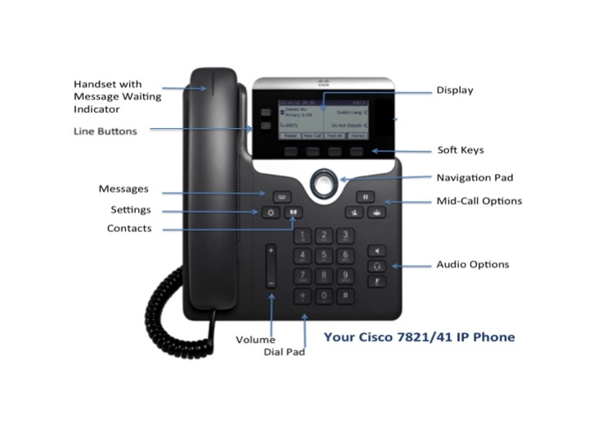

# Cisco IP Phone 7821

# Navigating

## Line Buttons

Two line buttons are located on the left of the display.

## Softkeys

Softkeys are feature buttons that dynamically change to reflect your current options. Four softkey buttons are located below the phone screen. You can press the **More** softkey (•••) when available to reveal additional options.

## Scrolling

To scroll though a menu or list, press the up or down arrows on the Navigation Pad. 

A scroll bar on the screen indicates your relative position within a list. Press the middle of the Navigation Pad to make your selection.

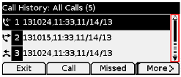

# Dialing

To place a call, pick up the handset and enter a number. Or, try one of these alternatives.

## **Redial the last number**

Press the Redial softkey to redial on your primary line. To redial on a secondary line, press the line button first.

## **Dial on-hook**

1. Enter a number when the phone is idle.
2. Lift the handset or press a line button, the Call softkey, the Headset button , the Speakerphone button, or the round Select button in the Navigation pad.

# Answer a Call

New call indicators:

* A flashing amber line button
* An animated icon and caller ID
* A flashing red light on your handset

To answer the call, lift the handset, press the flashing amber line button, the Answersoftkey, or the Headset or Speakerphone button.

## Answer with multiple Lines

If you are talking on the phone when you get another call, a message appears briefly on the phone screen. Press the flashing amber line button to answer the second call and put the first call on hold automatically.

# Hold

Press the Hold button . The hold icon appears and the line button flashes green.

To resume a call from hold, press the flashing green line button, Resumeor Hold softkey.

# Transfer

1. From a connected call (not on hold), press the Transfer  button.
2. Enter the transfer recipient’s phone number.
3. Announce the call if you wish after the recipient answers. Then press the Transfer button or the Transfer softkey. Or you can press Transfer before the recipient answers.

# Conference

1. From a connected call (not on hold), press the Conference  button. This places the initial call on hold.
2. Make a new call.
3. Press the Conference button or the Conference softkey before or after the party answers. The conference begins and the phone displays “Conference.”
4. Repeat these steps to add more participants.

The conference calls ends when last internal Brown person hangs up.

## View and Remove Participants

During a conference, press the Details softkey. To remove a participant from the conference, scroll to the participant and press the Remove softkey.

# Cisco IP Phone 7821

# Voicemail

When you have voicemail messages waiting, you will see two new message indicators:

* A solid red light on your handset
* New voicemail icon (O_O) on your display

## Listen to Messages

Press the Messages button  and follow the voice prompts. To check messages for a specific line, press the line button first.

If you forget your voicemail PIN, send an email to [voicemail@brown.edu](mailto:voicemail@brown.edu) or call 32007.

## Divert to Voicemail

Press the Declinesoftkey when the call is ringing, active, or on hold. Divert sends an individual ringing call directly to your voicemail.

# Forward Calls

1. To forward calls on your primary line to another number, press the Fwd All softkey.
2. Enter an internal 5-digit phone number or press the Messages button to forward all calls to your voicemail.
3. Look for confirmation of the forward on your phone display.
4. To cancel call forwarding, press Fwd Off.

# Directories

You can use the Directories to search for and call any colleague by name.

1. Press the Contacts button .
2. Select a directory using the Navigation pad arrows to scroll through the list and the center Select button to choose a directory.
3. Use your keypad to input search criteria. Use the backspace softkey to undo.
4. Press the Search softkey.
5. To dial, scroll to a listing using the navigation pad and press the Dial softkey.

# Call History (Recents)

To view your call history:

1. Press the Applications  button.
2. Press the center button of the Navigation pad to select Recents.
3. Select a line to view. Your phone displays the last 150 missed, placed and received calls.
4. To view details for a call, scroll to the call and press the More (•••) softkey, then press Details.
5. To dial from the call history, scroll to a listing then either lift the handset, press a line button, or press the Select button.

To edit a number before dialing, press the More softkey then EditDial.

# 

**Quick Reference Guide**



CISCO **7821** IP Phone