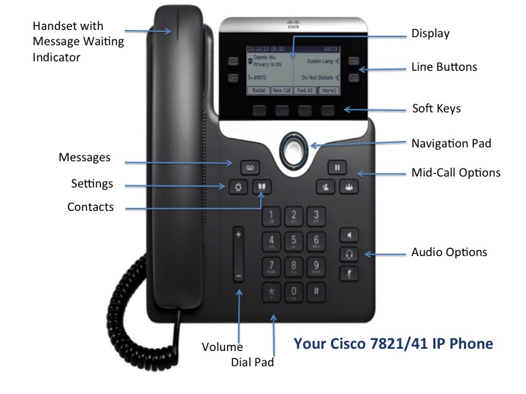

# Cisco IP Phone 7821

# Navigating Your Phone

## Line Buttons

Line buttons are located on both sides of the phone screen. Buttons that are not assigned to phone lines can be used for speed-dials and other features.

## Softkeys

Softkeys are feature buttons that dynamically change to reflect your current options. Four softkey buttons are located below the phone screen. You can press the More softkey when available to reveal additional softkeys. 

## Scrolling

To scroll though a menu or list, press up or down on the Navigation buttons on the Select bar. 

A scroll bar on the screen indicates your relative position within a list.

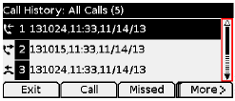

# Dialing

To place a call, pick up the handset and enter a number. Or, try one of these alternatives.

## **Redial the last number**

Press the Redial softkey to redial on your primary line. To redial on a secondary line, press the line button first.

## **Dial on-hook**

1. Enter a number when the phone is idle.
2. Lift the handset or press one of these: a line button, the Call softkey, the Headset button , the Speakerphone button, or the round Select button in the Navigation bar.

## Speed dial

Enter a speed-dial item number and press the SpeedDialsoftkey. Or, press the downarrow on the Navigation bar when the phone is idle, then scroll to a speed-dial item and press the round Selectbutton in the Navigation bar. You may also have speed dials assigned to some buttons along the right side of your phone.

# Answer a Call

New call indicators:

* A flashing amber line button
* An animated icon and caller ID
* A flashing red light on your handset

To answer the call, lift the handset. Or, press the flashing amber line button, the Answersoftkey, or the unlit Headset or Speakerphone button.

## Answer with multiple Lines

If you are talking on the phone when you get another call, a message appears briefly on the phone screen. Press the flashing amber line button to answer the second call and put the first call on hold automatically.

# Hold

Press the Hold button . The hold icon appears and the line button flashes green.

To resume a call from hold, press the flashing green line button, Resumeor Hold.

# Transfer

1. From a connected call (not on hold), press the Transfer  button .
2. Enter the transfer recipient’s phone number.
3. Press the Transfer button or the Transfer softkey (before or after the recipient answers).

The transfer completes.

# Conference

1. From a connected call (not on hold), press the Conference  button.
2. Make a new call.
3. Press the Conference button or the Conference softkey (before or after the party answers).

The conference begins and the phone displays “Conference.”

1. Repeat these steps to add more participants.

The conference ends when all participants hang up.

## View and Remove Participants

During a conference, press the Details softkey. To remove a participant from the conference, scroll to the participant and press the Remove softkey.

# Cisco IP Phone 7821

# Voicemail

When you receive a new voicemail message, you will notice these three message indicators:

* A solid red light on your handset
* A stutter dial tone (for visually impaired users)
* “New Voicemail” message on your phone display

## Listen to Messages

Press the Messages button  and follow the voice prompts. To check messages for a specific line, press the line button first.

## Divert to Voicemail

Press the Divertsoftkey when the call is ringing, active, or on hold. Divert sends an individual ringing call directly to your voicemail.

# Forward Calls

1. To forward calls on your primary line to another number, press the Fwd All softkey.
2. Enter a phone number or press the Messages button to forward all calls to your voicemail.
3. Look for confirmation of the forward on your phone display.
4. To cancel call forwarding, press Fwd Off.

# Directories

You can use the Directories to search for and call any colleague by name.

1. Press the Contacts button .
2. Select a directory using the Navigation bar and Select button to scroll and select.
3. Use your keypad to input search criteria.
4. Press the Submit softkey.
5. To dial, scroll to a listing and press the Dial softkey.

# Call History

To view your call history:

1. Press the Applications  button.
2. Select Call History.
3. Select a line to view.

Your phone displays the last 150 missed, placed and received calls.

1. To view details for a call, scroll to the call and press the More softkey, then press Details.
2. To dial from the call history, scroll to a listing then either lift the handset, press a line button, or press the Select button.

To edit a number before dialing, press the More softkey then EditDial.

# 

**Quick Reference Guide**



CISCO **7821** IP Phone